Effects of Pollution on Rising Water Levels in Wetlands
Name
Institution
Date

Effects of Pollution on Rising Water Levels in Wetlands
The world has been experiencing a couple of climatic changes in recent days and associated with pollution. As Hao (2021) mentioned, pollution is the introduction of harmful materials into the environment, the pollutants. The pollutants can be natural, like volcanic or due to human activities. In the real sense, human activities like industrialization, deforestation, and agricultural activities are the primary water and air pollution courses. Pollution affects wetlands and marine ecosystems as well (Hao, 2021). Pollutants in the groundwater and freshwater surface that moves into wetlands cab be toxic to both plant and animals if they accumulate on the wetland sediments. These invasive substances alter the composition and wetland communities. The wetlands are usually calm under ordinary circumstances and can naturally match the pace of changing sea levels (Tang et al., 2019). Due to climate change, the sea levels rise and are projected to many coastal wetlands like Florida. When the wetlands are affected, other sectors like the tourism and hospitality industry are affected. This paper examines in depth the effects of pollution on wetlands like Florida. This will be analyzed by addressing the background of the problem, offering solutions to the problem, and addressing advertisements.
Background Information
Causes of rising water levels
- Ice melting from the land into the ocean
Ice melts from the land into the ocean, which has been happening in modern days due to climate changes (Rayner et al., 2021). Human activities are the root of this phenomenon. Mainly, since the initiation of the industrial revolution, greenhouse gases like carbon dioxide emissions have resulted in a rise in temperatures all over the world (Sea Level Rise. Org, 2020). The rise in temperatures in the poles leads to rapid melting of glaciers, calving off into the sea, and the impact is felt on land, especially on the areas around the sea.
- Warming water that expands
The concept of thermal expansion can be used to describe how water bodies expand. Higher temperatures result in the thermal expansion (Rayner et al., 2021). The seas and oceans absorb heat from the atmosphere when there is an elevation of atmospheric temperatures. The water then expands and results in an increased volume of water in the oceans.
- Slowing gulf
In case the Gulf Stream slows, the earth can experience disaster. Currently, there is a lack of consistency and predictable shifting around water, resulting in dramatic sea levels, especially on the east coast of the U.S (Sea Level Rise. Org, 2020). Florida is among the states in the U.S that could be adversely affected by the rising water levels. The place will also experience extremely cold winters, and there will be devastating disruptions in the monsoon seasons all across Europe.
Risks of Rising Sea Levels on Wetlands
- Impacts on health and transportation
When the sea levels rise, flooding happens on the Wetlands. The chances of infection outbreaks in the affected area are high. In this case, waterborne infections and cholera are higher chances of happening (Davis et al., 2017). The transportation industry turns out to be much affected, and all the tourism activities are affected as well.
- Effects on Tourisms
The beaches and other fascinating places around the sea have been attracting tourists. As mentioned by Sea Level Rise. Org, (2020), the New Jersey’s beaches account for 70% of the state’s tourism revenue and support 10% of all the jobs within the state. New Jersey makes approximately $36.4 billion from the tourism industry. Tourism activities indeed keep the economies of wetlands moving (Sea Level Rise. Org, 2020). The rise in sea levels erodes natural resources like dunes and barrier islands and thus resulting in higher chances of flooding and threatening the growth of the wetlands. Florida has interesting beaches and sea shows as well. The money from visitors supports many businesses. The state makes at least $ 40 billion annually from the tourism industry—Tourisms are the primary source of income. Therefore, an increase in sea levels will prevent the state from running its affairs normally.
- Endangered species losing habitats
The rise in sea levels disrupts coastal wetlands by drowning some species of plants. In addition, there are chances that the seawater will increase salt levels in the soil and water on land (Appannagari, 2017). All these series of happenings constitute a significant threat to the ecosystems, both marine and wetlands habitats, and people are in danger of experiencing storms. More importantly, the tourists are afraid of visiting the wetlands when there are threats of storms.
Solutions
- Public education
The primary cause of the rise in the sea levels is pollution on air. Human activities like deforestation and exhaust fumes from industries and cars have affected polluted the air. This results in the rise of temperatures and thermal expansion and hence an increase in water levels (Sea Level Rise. Org, 2020). Therefore, public education on minimizing pollution on air will offer the most effective solution to rising sea levels. Industries need to be informed on the necessity of controlling the gases they release to the environment. People should as well stop deforestation, adopt reforestation and let the natural forests undisturbed.
- Applying new technology in buildings
Currently, the constructors and builders are motivated to adopt green building practices (GBP). The GBP, are essential in developing sustainability site and creating eco-friendly building materials. In addition, the places around the Wetlands need to be taken good care of, and this can be done through elevating the building. The homeowners experiencing repeated flooding can apply HVAC systems, plumbing and electric meters on their floor as shown in fig 1. (Sea Level Rise. Org, 2020). This will prevent future damage due to flooding from the sea. However, this system of the building is much expensive and not affordable by many people. The prominent hotels can be designed using these modern building styles, and this will keep the tourism activities in progress even when the sea levels rise.
- Building seawalls and rising roads.
The wetland states like New Jersey and Florida can adopt the waterproof perimeter walls around the sea. New York City has initiated a plan to build a $ 335 million flood wall in Manhattan, and this will lower the flooding from tides and storms. This has been well shown in the fig 2. The project is much costly but worth it in ensuring that essential industries like tourism are running progressively.
Fig 3 shows how Miami beach has a running project of raising the road by 2 feet (Sea Level Rise. Org, 2020). When the sea levels rise, transportation will still run normally. Transport and tourism industries are closely connected, and one cannot succeed without another.
Application of models in solving the problem
SWOT analysis
The SWOT analysis is applicable in helping firms to minimize taking advantage of the chance. Many companies that produce pollutants to the environment have outstanding strengths like skilled workers, value recognition, and focus on realising their set goals. The firms as well build good customer relationships. The primary weaknesses include focusing on addressing their goals and giving slight preference to the existing environmental issues. Some companies are never worried about the pollution they cause to the air, which is a primary weakness (Ajmera, 2017). In addition, other firms know how to take the existing opportunities for their benefit. For example, in some cases, the government is less concerned about confirming if the companies control pollution. This might turn out as an opportunity for some firms to discharge harmful wastes on the environment. The significant threats concerning companies and pollutions come when climate changes, rising sea levels, and reducing tourism activities (Ajmera, 2017). The firms need to identify such threats and act upon them as a method of controlling their operations. The changes in legal, political and social perspective might also affect the firm, which relies on tourists as their primary consumers.
STP Marketing model
The STP marketing model emphasises on segmentation, targeting, and positioning of firms. In the segmentation phase, the primary focus issue is identifying groups of customers and dividing the market into identifiable and dissimilar segments (Shah et al., 2019). Targeting has to do with determining the group of customers to aims for in planning marketing strategies. Positioning determines the success of the companies, and it involves creating a concept that appeals to the target markets to occupy the most favourable places that will stick to the customers' mindset (Shah et al., 2019). The tourism industries of different countries can use this model to achieve competitive advantages over others. For example, the idea of Miami raising the roads to prevent disruption of transportation activities is a good one for winning more tourists over the other wetlands.
The riffle effects
The ripple effect refers to the activity or action that disperses and affects other industries after its onset. This model suggests that when more focus is made on preventing pollution, the environment will become more attractive for people, and more income can be achieved (Dolgui et al., 2018). For example, when the industries worldwide control their pollution activities to the environment, other sectors will benefit maximally, like the tourism industry. There will be a few rising sea levels incidences, and the wetlands will remain stable. In return, more visitors will be present in an area like Florida and Miami beaches, generating revenue for the states.
Advertisement
The Florida Department of Environmental Protection (FDEP) regulates the wetland in collaboration with the United States Environmental Protection Agency (EPA). The two organizations are committed to ensuring the wetlands and maintained and all the species within the area, including humans, are protected. The FDEP is calling for public support to collect all the plastics around the wetlands to hinder the free interaction of the marine animals with their environment. In addition, EPA is much committed to ensuring that tourism activities run smoothly within the countries. The government agencies are taking actions towards pollution from the industries either in water or air. The actions being initiated to mitigate the over pollution is hiring include taking innovative ideas from the citizens on preventing pollutions. There are known air pollution technologies like cyclones, scrubbers, and electrostatic precipitators (ESP). The ESP is a filterless device that traps and removes fine particles, including smoke, from flowing gas. Industries need to get the ESP and implement other advanced technologies for reducing pollution. This will, in turn, lead to reduced elevation of sea levels, and in turn, promote continual progress of tourist activities.
Conclusion
Human activities are the primary causes of pollution in the environment. In the modern days, the effects of pollution are being experienced by the rising water levels that affect the wetlands like Florida. The entire ecosystem is endangered, and tourism activities are affected negatively. Thermal expansion and slowing gulf result in a rise in the sea levels. The impact is felt by disruption of tourist activities due to problems in transportation and coverage of the recreational beaches. Tourism is the leading revenue-generating sector in states like Florida. There is a need for public education on the possible ways of preventing pollution. To correct what has already gone wrong, the wetlands have buildings adaptable to the flooding conditions constructed. The building of seawalls and raising roads are solutions as well. The primary advertisement in this white paper is the policies of the Florida Department of Environmental Protection (FDEP) and the United States Environmental Protection Agency (EPA) committed to ensuring the effects of pollution are minimal and thus saving the tourism industry in the wetlands.

References
Ajmera, P. (2017). Ranking the strategies for Indian medical tourism sector through the integration of SWOT analysis and TOPSIS method. International journal of health care quality assurance.
Appannagari, R. R. (2017). Environmental pollution causes and consequences: a study. North Asian International Research Journal of Social Science and Humanities, 3(8), 151-161.
Davis, J. L., & Vinogradova, N. T. (2017). Causes of accelerating sea level on the East Coast of North America. Geophysical Research Letters, 44(10), 5133-5141.
Dolgui, A., Ivanov, D., & Sokolov, B. (2018). Ripple effect in the supply chain: an analysis and recent literature. International Journal of Production Research, 56(1-2), 414-430.
Hao, Y., Niu, X., & Wang, J. (2021). Impacts of haze pollution on China's tourism industry: A system of economic loss analysis. Journal of Environmental Management, 295, 113051.
Rayner, D., Glamore, W., Grandquist, L., Ruprecht, J., Waddington, K., & Khojasteh, D. (2021). Intertidal wetland vegetation dynamics under rising sea levels. Science of The Total Environment, 766, 144237.
Sea Level Rise. Org. (2020). Rising Sea Levels solutions. Retrieved from https://sealevelrise.org/solutions/
Shah, S. A., Azhar, S. M., & Bhutto, N. A. (2019). Halal marketing: a marketing strategy perspective. Journal of Islamic Marketing.
Tang, J., Yuan, X., Ramos, V., & Sriboonchitta, S. (2019). Does air pollution decrease inbound tourist arrivals? The case of Beijing. Asia Pacific Journal of Tourism Research, 24(6), 597-605.
Appendices

Fig1: A raised house projection

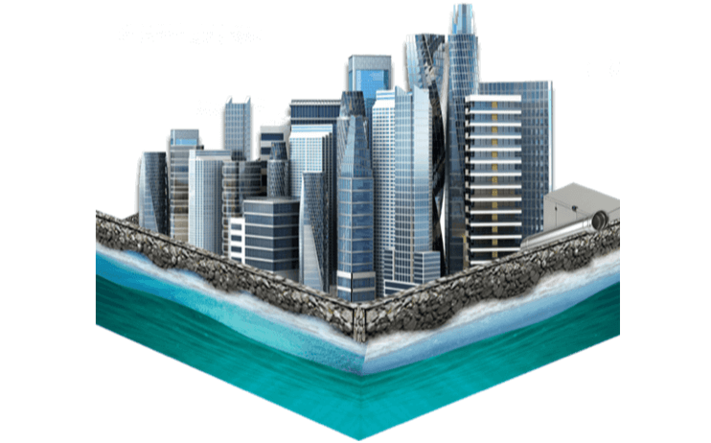
Fig 2: Projected seawall in Ney York City
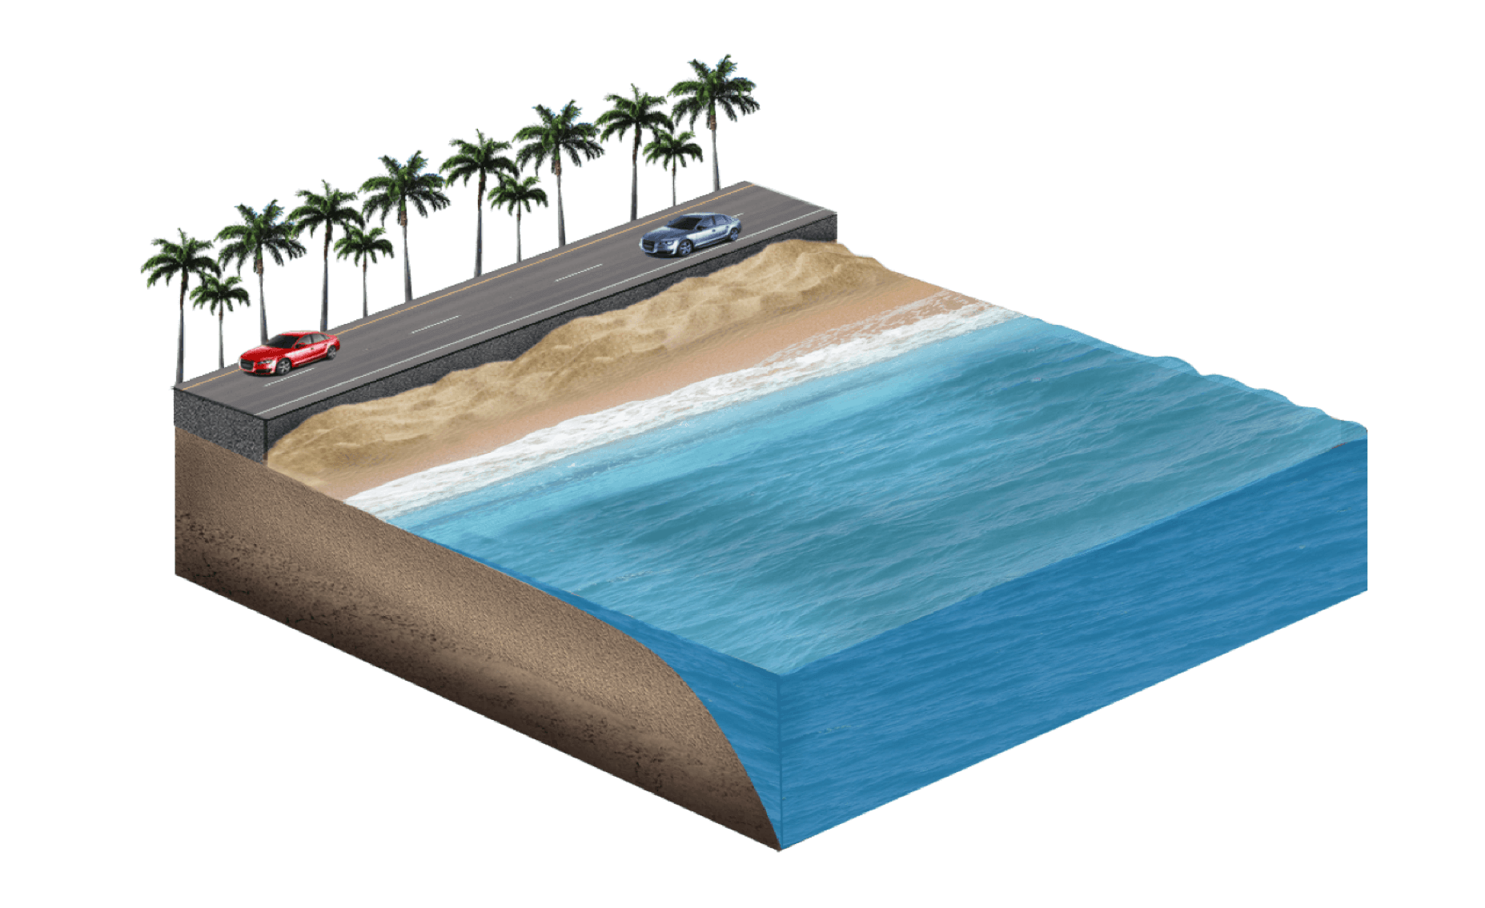
Fig 3: A raised road projection.

